CURRICULUM VITAE

Dr.S.SMITHA
Principal & Associate Professor in Sericulture
Department of Sericulture
S.T.S.N.Govt.Degree College, Kadiri

Areas of Research: | Impact of Selenium on some Biohemical and histological aspects of Silkworm B.mori.L Selenium and Silkworm Nutrition in terms of Impact on Insect Physiology, Bio chemistry and histology
Teaching Experience: | 24 Yrs
Research Experience: | 20 yrs

Academic Profile:

Degree | Year | University | Subject | Percentage | Grade
B.Sc | 1990-1993 | S.V.University, Tirupathi | Botany, Zoology and Chemistry | 77.1 | Distinction
M.Sc., | 1993-1995 | Mahila University, Tirupati (SPMVV) | Sericulture | 78.4 | Distinction
M.Phil. | 1999-2002 | Sri Krishndevaraya University, Ananthapuramu | Impact of Selenium on some physiological and Cocoon commercial Charecters of Silkworm B.mori | 75.5 | Distinction
Ph.D. | 2002-2007 | Sri Krishndevaraya University, Ananthapuramu | Impact of Selenium on some Biohemical and histological aspects of Silkworm B.mori.L | Awarded | First Class
UGC NET | 1995 | UGC accredited | Sericulture/Zoology |  | Qualified

Employment Profile:

S.no. | Position | Period | No. of years
1 | Asst. Professor (Lecturer) | 1996-2002 | 6years
2. | Asst. Professor-Senior Grade | 2002-2006 | 4 years
3 | Asst. Professor-Selection grade | 2007-2009 | 3 yrs
4. | Reader | 2009 till 2012 | 7yrs
5 | Professor | 2012-2020 | 8 yrs
6 | Principal | From 14th January 2020 | Till todate

Current Research Experience:

Position | Year | Organization | Description
As Research Scholar | 1999-2007 | Sri Krishndevaraya University, Ananthapuramu | M.Phil entitled “ Impact of Selenium on some physiological and Cocoon commercial characters of Silkworm B.mori.L  Ph.D entitled “Impact of Selenium on Certain Bio chemical and Histological aspects of Silkworm Bombyx mori.L
As Principal Investigator | 2008-2010 | S.T.S.N.GOVT.DEGREE COLLEGE,KADIRI | Carried out UGC minor research project on “Ericulture in Kadiri-an Institute- Village linked Programme on Feasibility, Technology Development, Transfer and Refinement”.

Research Papers Published: 10 International+5 national+7 in proceedings of international seminar and 17 abstracts in proceedings of National seminars

Awards and recognitions as a student:

S.No | Year | Award/Recognition
1 | 1988 | School II rank
2 | 1993 | College I Rank in B.Sc BZC, SVU.Tirupathi
3 | 1993 | Best out going Student
4 | 1993 | Ganana Jyothy award
5 | 1995 | University II rank in M.Sc Sericulture,SPMVV,Tirupathy
6 | 1995 | U.G.C- NET (National Eligibility Test) for Univ. Lecturers.

Awards received as a Faculty:

- Received State Best teacher Award in 2010 by the A.P.State Government
- Received Grants from UGC, DBT, APSCHE, APCOST towards Minor research Project and Organization of National Seminar

Academic activities:

- Chairman- Board of Studies, Dept. of Sericulture, SK.University, Ananthapur
- Organizer-National seminar on “Cutting Edge technologies in vanya Silk Research –India”
- Delivered Talks , as Resource person, for UNNATI skill development institute Kadiri
- Delivered Talks , as Resource person for professional school, RDT,ATP
- As Invited Lecturer for University,n Degree colleges,Junior colleges and Schools

Acted as Coordinator for following schemes:

Position Held
JKC Coordinator | Acted as Coordinator for 2 academic years 2009 – 10 and 2010-11 and 35 JKC trained have got placements in Sparsh BPO, Bangalore in Job mela organised at Anantapur 2010  Photo annexure enclosed
Women Empowerment Cell Coordinator | As Coordinator of Women Empowerment Cell  Enclosed Annexure
UGC NWRC coordinator | Acted as coordinator and creating awareness among staff and students regarding computer basics - Enclosed Annexure
Career Guidance Cell Coordinator | Playing key role in creating knowledge resources.
Controller of Examinations | Acted as incharge chief controller of exams.
In charge Principal | Many times acted as incharge of principal at need times.
Any Other responsibility assigned by the department/ principal of the college | Being the head of the department and senior most lecturer my services are utilized by the college in various ways.  As Chief Superintendent of the examinations  As chief Superintendent of B.Ed Examinations  As Chief of POLYCET-2013  As joint chief of POLYCET-2016  Acting as coordinator for UGC schemes.  As Custodian of SKU Public Examination question Papers  Acted as convener of IQAC-2005

Community development activities:
Being a Human…
- Poor Student funding at need times
- Rallis against women atrocities
- Taken initiation to plant 300 plants in the campus towards The GREEN MOVEMENT-Fight against Green House Effect
- Organizing a mid day meal programme for Sericulture students
- Participated in indo American free eye camp at Kalasamudram,Kadiri

- Participated and Contributed in Free Medical Camps ( general)-

- Participated in Awareness camp on RTI
- Organised Awareness camp on Voter’s rights
- Conducted Women’s day celebrations for encouraging rural girl child towards education
- Donations to Ramakrishna Matt, Kadapa for orphanage.
- Donation to Bhagavan ramana maharshi Ashram, Arunachalam.

Personality development activities:
As coordinator of Career Guidance and Counselling cell
- Organized 2 Job Melas
- Organized Interactive workshop on ‘Communication skills’
- Organized Interactive workshop on ‘Career options to graduates
- Organized Interactive workshop on ‘Soft skills’
- Organized Interactive workshop on ‘Positive attitude’.
- Organized Improvement of Skills in Interview- Awareness Programme
- Interactive workshops on ‘Personality development and Human values’

Books/Chapters authored:

- Authorized ac Book titled Selenium and Silkworms -Discovery Publishing House Pvt. Ltd., New Delhi in 2012.
- Contributed Chapter in the subject; “Haemolymph Trehalose and Fat body Glycogen Phosphorylase- Interrelationship in Silkworm Bombyx mori L. Chronically exposed to Fluoride” in Book on “ Recent Trends in Sericulture” Published by Narendra Publishing House, Delhi – 110006 (India) in 2011
Minor Research Projects:

S.No | Title of the Project | Funding  Agency | Duration | Financial  Assistance | Status of the project
1. | Ericulture in Kadiri- an institute- village linked programme on feasibility, technology development, refinement and transfer. | UGC  (Minor) | 2008-10 | 75,000 | Completed

2.DBT funded POPULAR LECTURES IN BIOTECHNOLOGY BY EXPERTS

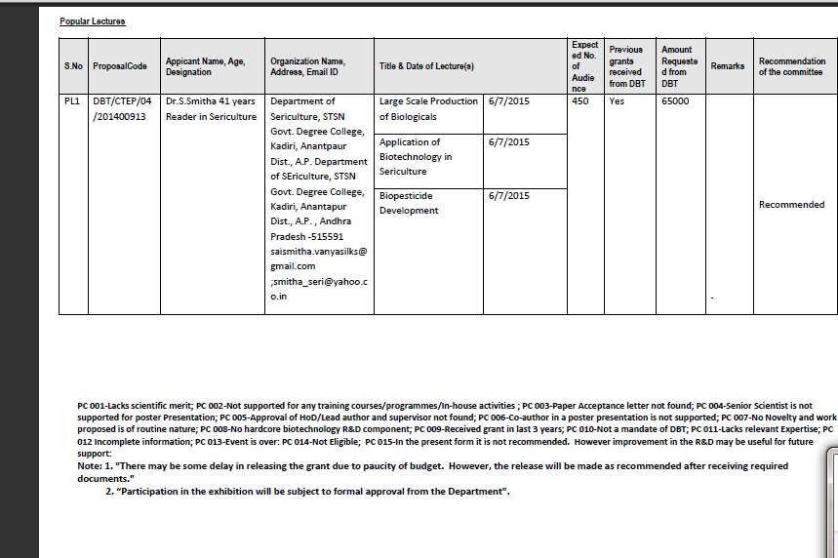

National Seminar Organized:
National Seminars Organized History
Details of Previous Grants Received from DBT for any Event
National Seminar on"Cutting Edge Technologies in Vanya silk Research- India ”
Sponsored by UGC, DBT, APSCHE, APCOST-2012

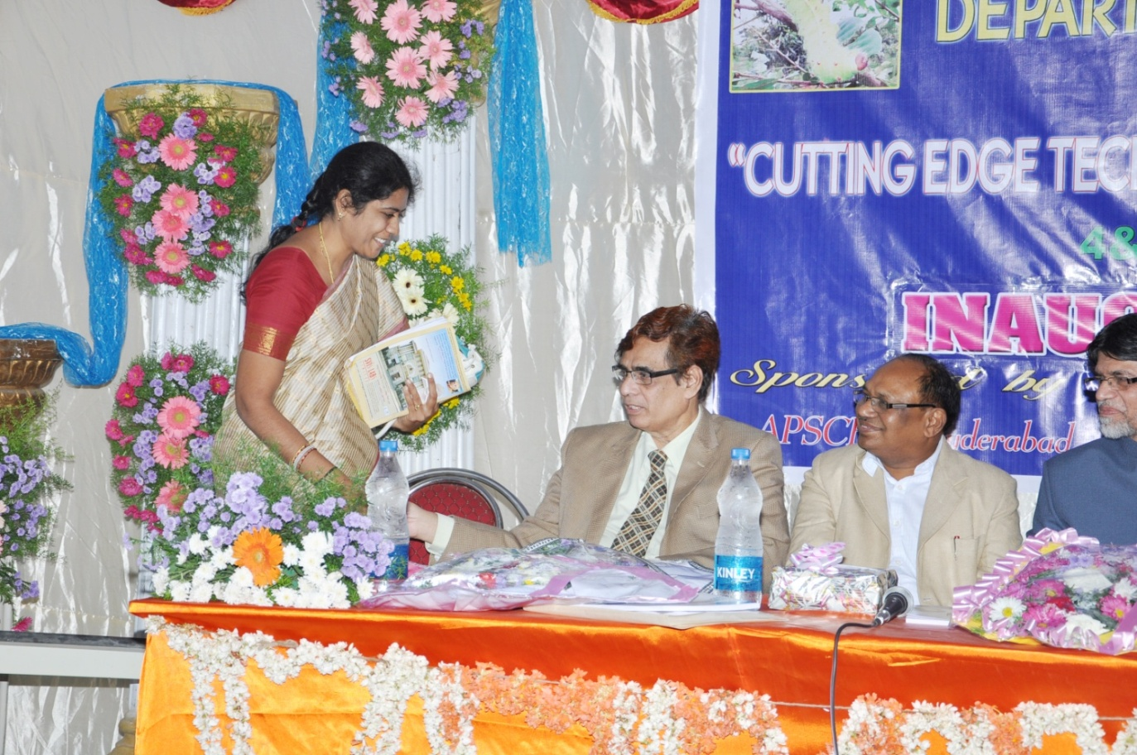

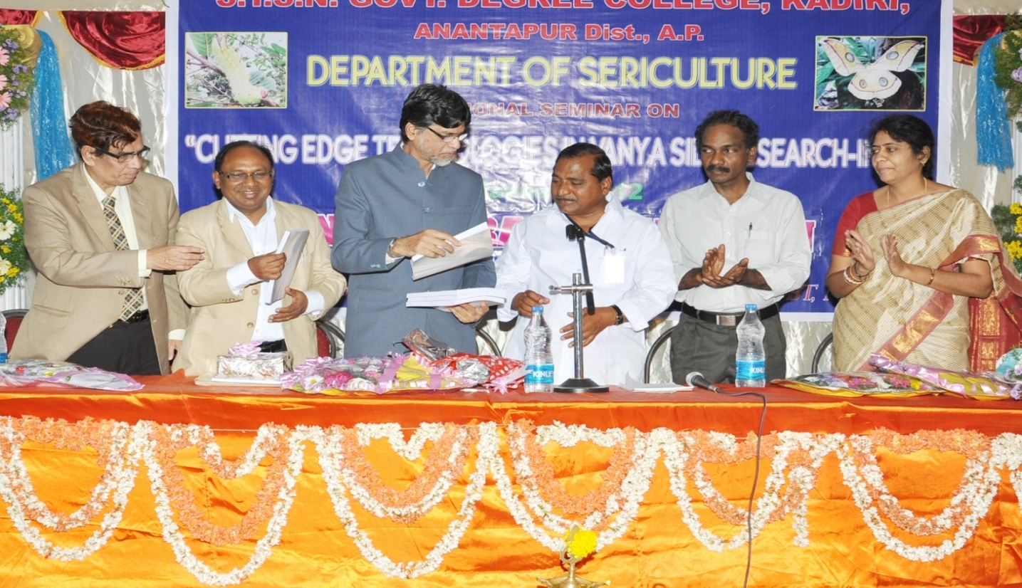
Conferences/Seminars /workshops attended
Dr.S.Smitha, Reader in Sericulture
S.No. | International/National seminar/workshop | University/College  organized | Date and year
 | 3 day Orientation Programme | Commissionerate of Collegiate Education | 12th - 14th Feb 2020
 | NPTEL SWAYAM Workshop | IIT Madras | 15 th Dec.2018
 | One week Orientation Workshop“OER CONTENT DEVELOPMENT MOOCS AND MOODLE” | Ministry of Electronics and Information Technology, Govt.of India with Electronics and ICT Academy National Institute of Technology, NIT Warangal and CCE, APSCHE, Govt.of AP | 26th-31st Oct.2018
 | Special Workshop “Value based Education” | Ramakrishna Mission ashrama, KADAPA. | 10th-12th Aug.2018
 | ICSSR sponsored National Seminar  “Performance, Problems And Prospects of MSMEs In India” | Commerce GDC(Men) | Dept.of 28th-29th July 2017.
 | Zonal level one day workshop on E-Office | Administrative Cell GDC,Atp | 18.11.2017
 | STEM teacher Training Workshop on Research Based Pedagogical Tools | British Council, Newton Bhabha Fund,MHRD,SHcollege,DBT, IISER,Pune, Kochi, KERALA | 11.10.2017-14.10.2017
 | State Level Faculty Development Programme | AP Human Resource Development Institute, Govt.of A.P, Bapatla | 9.8.17-11.8.17
 | Special workshop for Teachers on Values education | Ramakrishna Mission,Kadapa | 8-10th Sept.2017
 | National Seminar on Impact of Human Values and Professional ethics on the Quality of higher Education | GDC, Uravakonda | 23rd & 24th. Jan.2017
 | Special workshop on Value education | Ramakrishna Mission,Kadapa | 9.9.16-11.9.16
 | National seminar Skill development courses to empower  Higher education | Organized by  IQAC & SDC  GOVT. DEGREE COLLEGE URAVAKONDA-515 812  (Accredited at “B” Grade by NAAC)  ANANTHAPURAMU DIST., A.P. | 26 th & 27th october 2016
 | International Conference on  Computational, Mathematical and Biological Modelling  (ICCMBM16) | Jointly organized by  Departments of Computer Science, Applied Mathematics and Sericulture  SRI PADMAVTI MAHILA UNIVERSITY  TIRUPATI -517502 | 25th – 26th March, 2016
 | National work shop on Choice Based Credit System | Board of stuies, S.K.University | March 30th2016
 | National Seminar on “Trends for advancements of Sericulture” | Dept.of Sericulture, S.K University, Anantapuramu | 21st & 22nd January-2016
 | ” International E-Lecture workshop on ‘Advances in Science & Technology | Sri Padmavati mahila Viswa Vidyalayam, Dept.of Sericultue, Tirupati in association with Bio ADD Centre,Stanford school of Medicine,STANFORD UNIVERSITY, California 94305 USA. | 22^{nd&}23rd .June-2015
 | National seminar on ‘Sustainability and management of aquatic Eco systems in Semi arid areas | Govt.Arts college, Men, Ananthapuramu,SKU | 7th & 8th.Jan.2015
 | National Seminar on “Recent Trends in Biology & its applications” | Department of Botany and Zoology,SKP GDC, Guntakal, Atp.Dt | 29th January2015
 | National seminar on Plant biotechnology for better future | Govt.Arts college, Men, Ananthapuramu,SKU | 27th & 28th .June.2014
 | Special workshop on Value education | Ramakrishna Mission,Kadapa | 7.2.14-9.2.14
 | National seminar on Cutting edge technologies in vanya silk research-India | Department of Sericulture  STSNGDC,Kadiri | 4 & 5th January 2012
 | National seminar on DNA Barcoding | SPMVV, Women’s University, Tirupathi | Aug 9-10.2012
 | The national academies of Sciences.  E-lecture workshop on Genomics and proteomics | SPMVV, Women’s University, Tirupathi | 17-18,Aug’2010
 | National workshop on Seri-Bio informatics | S.K University,Dept.of Sericulture, Anantapur | 30-31st,March-2010
 | Emerging trends in Biotechnology | Dept.of Biotecnology, Govt college, Anantapur | 4-5 dec,2009
 | Annual convention of AP akademi of sciences and National symposium on science in 21st century | Sri Krishna Devaraya university, Anantapur | 5-6, Feb-2008
26 | International conference on Trends in Seri biotechnology | S.K University,Dept.of Sericulture, Anantapur | 27-29,March 2008.
27 | National seminar on scenario of seribiotechnological research in India | SPMVV, Women’s University, Tirupathi | 28-30th Aug.2008
28 | AP Science congress 2008 | Jointly organized by  AP AKADEMI of SCIENCES and Osmania university | 14-16,Nov.2008

Few Selected Peer Reviewed Research Publications

 | International/National |  | Title | Published by
 | International |  | Techno Economic Feasibility of Ericulture | Research Journal of Agricultural Sciences.8(6).Non-Dec.2017  ISSN:0976-1675
 | National |  | Empowerment of rural youth through Sericulture in A.P-Present Scenario and Prospects ahead | Journal of Agricultural Extension and Management .Vol.XVIII Jan-June 2017.  I SSN 0976-3120
 | International |  | Selenium Bioaccumulation: Impact on the Fat Body Histology of Silkworm Bombyx. Mori L.” | SETAC, Europe 24th Annual meeting held at Basel, Switzerland.  11th – 15th May 2014, pp.320
 | International |  | Effect of Vermicompost of Sericulture Wastes on soil Bacterial Count, Dehydrogenase Activity and Soil Respiration. | Advances in Plant Sciences, An International Biannual Research Journal Published under the Academy of Plant Sciences, India.26 (I) 57 – 59, 2013  ISSN-0970-3586
 | International |  | Genetic diversity and Enzymes among selected silkworm races of Bombyx mori.L | International journal of Science and Nature.  IJSN., Vol.2(4)2011:773-777  ISSN 2229-6441
 | International |  | Metabolic status of Eri silkworm on feeding two host plants, castor and Tapioca at different temperatures.  (Black Caspian Seas and Central Asia Silk Association. BACSA)  Institute for Bio engineering, biotechnology and Environmental Protection-S.C. BIONING S.A. Bucharest, Romania. | 5th BACSA International Conference” Sericulture for Multi products- New prospects for development” SERIPRODEV  April-11th-15th 2011  Bucharest, Romania
 | International |  | Effects of Selenium on the Physiology of Heart Beat,  Oxygen Consumption and Growth in Silkworm Bombyx mori L. | American-Eurasian Journal of Toxicological Sciences 2 (4): 215-219, 2010  ISSN 2079-2050  © IDOSI Publications, 2010
 | International |  | Selenium induced changes on carbohydrate metabolism in haemolymph and fat body tissue of Silkworm Bombyx mori. l | Animal sciences  Biospectra: Vol.4(1), March 2009, pp 41-44  An international Biannual  Journal of Life sciences.  ISSN: 0973-7057
 | International | Physiological and Biochemical Responses of Samia Ricini to Selenium |  | 6th international conference on wild silk moths.  Tokyo university of Agriculture  Setagaya-Ku  Tokyto, Japan  Sepr.21-23,2010
 | International | Alternations in the Haemolymph Bio chemical Parameters of Silkworm Bombyx mori L. treated with Selenium |  | American- Euracian Journal of Toxicological Sciences 2 (1): 51-53,2010  ISSN 2079-2050  Idosi publications,2010
 | International | Efficacy of selenium on silkworm (Bombyx mori. L) cocoon characters. |  | International journal of Industrial Entomology. IJIE.(2006)
 | International | Bio energitics and commercial productivity of Eri silkworm Samia ricini Donovan in different temperature conditions. |  | Proceedings of 21st century International sericultural congress 2008 Athens, Greece

The Government of A.P. recognized the services, activities and achievements and honored with the State’s “Best Teacher” award for the year 2010

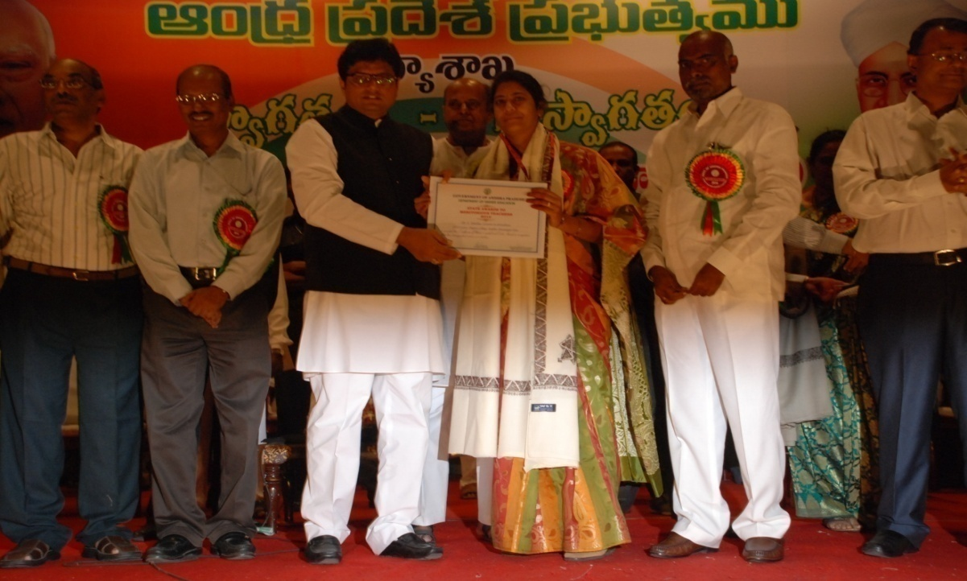
- Proud to deliver a talk on Personality Development through Human Excellence for Students of Proficiency college of Rural Development Trust founded by the greatest human being Father Vincent Ferror ji.

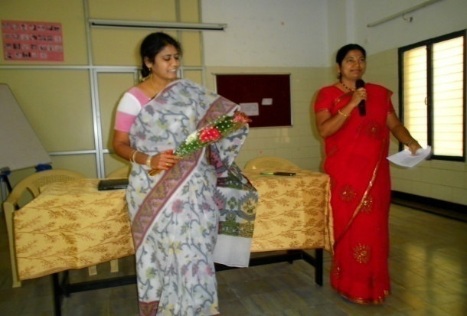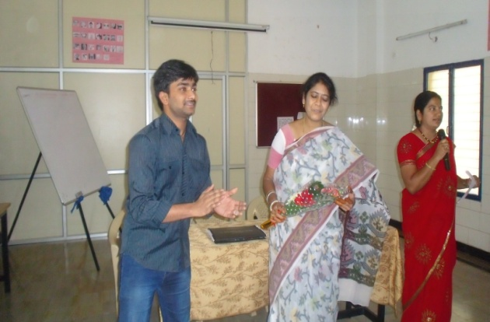
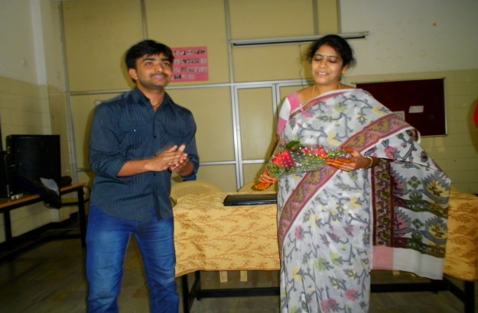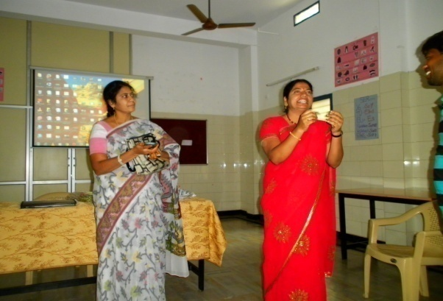
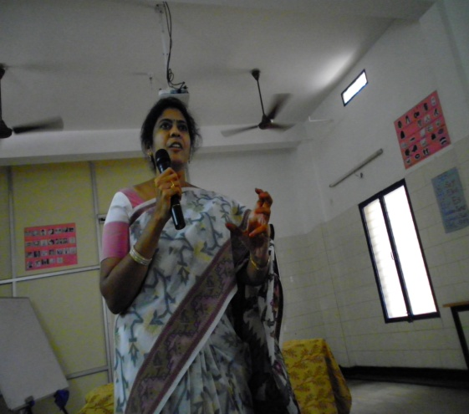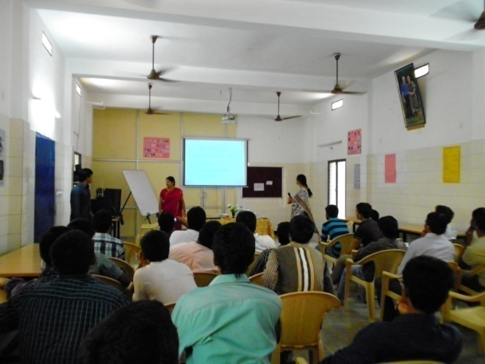
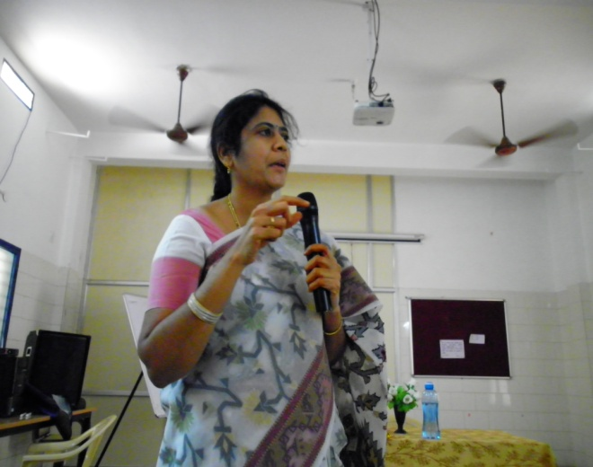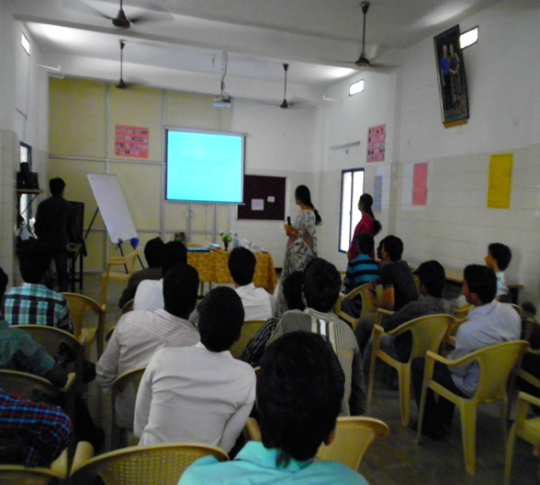

- A feel of responsibility to motivate the young minds towards development of skills lead me deliver a talk on Improvement of Skills at UNNATHI SKILL Centre KADIRI

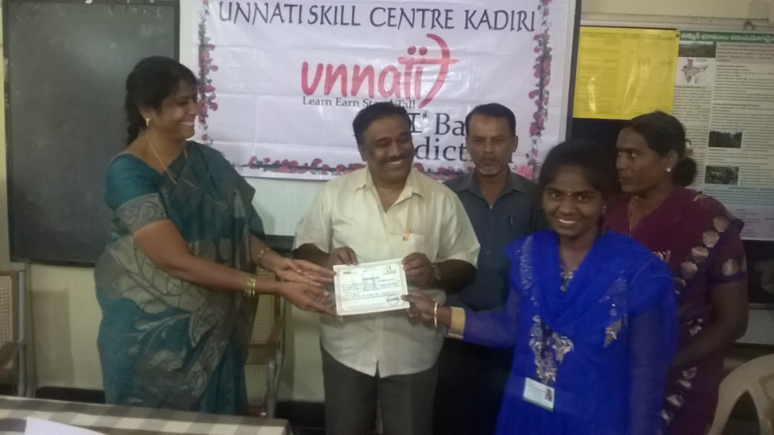

- Realizing the responsibility of bringing awareness among stake holders /community regarding the significance of tree plantation which provides Oxygen reducing due to the raise in temperature by absorbing Green house gasses such as Co2.nitrous oxide, Carbon monoxide etc..
